**Thresholding**

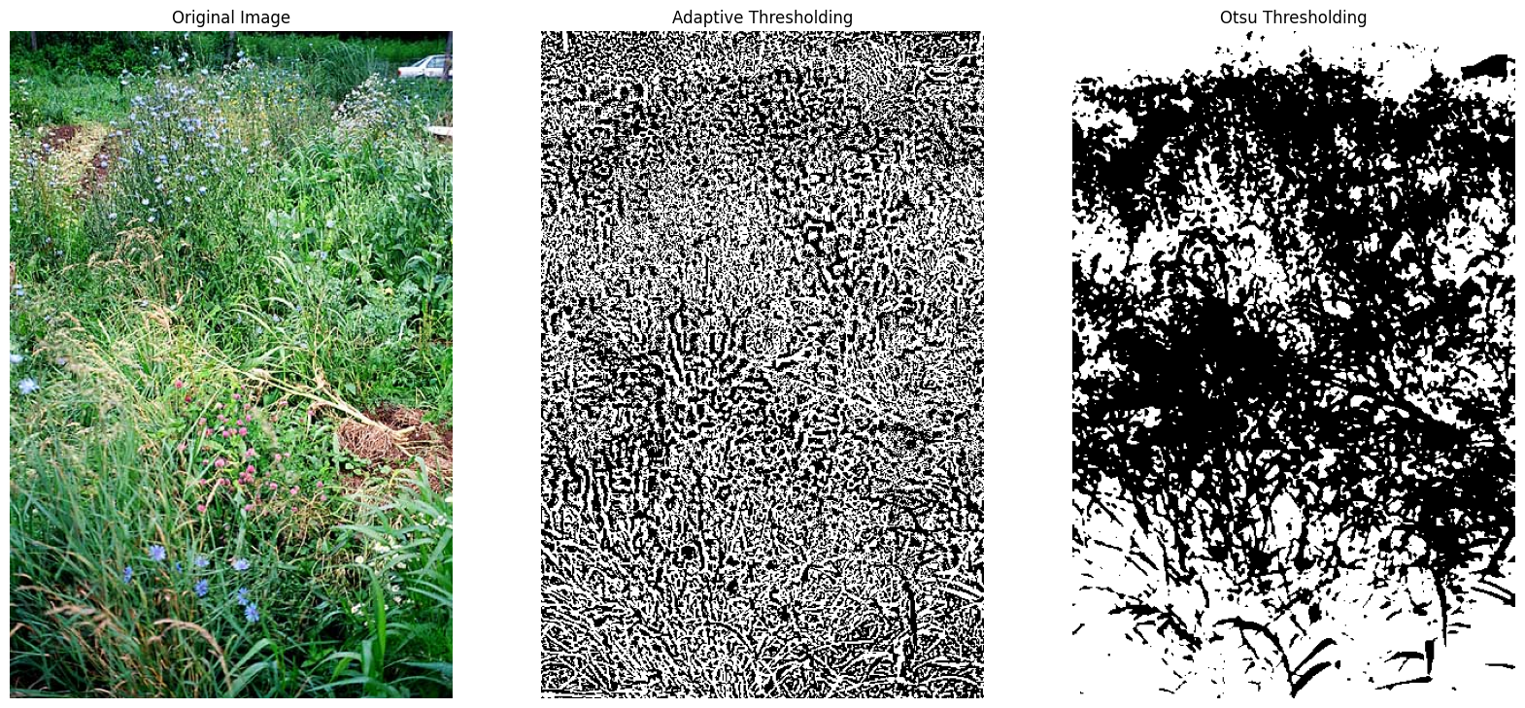

A: Thresholding Method Selection

**Adaptive Thresholding**: This method is likely the most effective for segmenting weeds from crops across varied lighting conditions. Unlike global thresholding, which uses a single threshold for the entire image, adaptive thresholding can calculate a threshold for smaller regions of the image. This adaptability allows it to handle shadows and uneven lighting more effectively. It considers local variations in intensity and is less affected by overall brightness changes in the image, making it suitable for images with variable lighting and adaptive thresholding will generate a more detailed image than Otsu.

B: Determining the Best Threshold

Since weeds and crops might have similar color profiles, especially if both are green, the threshold determination should go beyond color intensity. Converting the color space from RGB to HSV can help by isolating color information (hue) from brightness (value), potentially improving differentiation.

C: Preprocessing Steps:

**Histogram Equalization**: This technique can improve contrast in images, making the differences between weeds and crops more distinguishable, thus enhancing thresholding effectiveness.

**Color Space Transformation**: Converting the image to HSV or another color space can help separate luminance and chromatic information, which might help better distinguish between crops and weeds.

**Filtering**: Spatial filters, such as median filters, can reduce noise, while edge detection filters could help emphasize weed boundaries.

D: Supplementing Thresholding with Additional Features:

**Shape and Size Analysis**: By analyzing the morphology of segmented regions, features like shape and size could help distinguish between crops and weeds. For instance, weeds might have irregular shapes compared to the more uniform structure of crops.

**Texture Analysis**: Using texture-based features (e.g., using Gabor filters or Haralick texture features) can help differentiate weeds from crops based on their surface patterns.

E: Handling Occlusions and Overlaps:

**Advanced segmentation techniques**, such as the use of convolutional neural networks (CNNs) or other machine learning-based approaches, can handle partial occlusions by learning more complex features beyond mere pixel values.

**Morphological Operation**s: These can help refine segmented regions to overcome issues of occlusion and overlap by assessing morphological patterns.

F: Impact of Soil Moisture on Thresholding:

Variations in soil moisture affect its color and therefore the background intensity in images. Adaptive thresholding and color space transformations can mitigate some of these effects, but incorporating moisture level data as an additional input could further improve accuracy.

G: Addressing Varying Lighting Conditions:

Local Adaptive Thresholding and Preprocessing: Using adaptive thresholding tailored to local image patches can help balance lighting differences. Additional preprocessing steps, such as shadow removal techniques or normalization of lighting conditions, can further enhance thresholding performance.

**Histogram Equalization**: This could be applied globally or locally to address uneven lighting.

Code:

import cv2

import numpy as np

def preprocess_image(image):

hsv = cv2.cvtColor(image, cv2.COLOR_BGR2HSV)

hue, saturation, value = cv2.split(hsv)

# Apply histogram equalization to the Value channel

equalized_value = cv2.equalizeHist(value)

# Merge channels back

equalized_hsv = cv2.merge([hue, saturation, equalized_value])

return equalized_hsv

def adaptive_threshold(image):

# Perform preprocessing

preprocessed_image = preprocess_image(image)

# Convert to grayscale for thresholding

gray_image = cv2.cvtColor(preprocessed_image, cv2.COLOR_BGR2GRAY)

# Apply adaptive thresholding

blockSize = 11 # Size of the neighborhood area

C = 2 # Constant subtracted from the mean

adaptive_thresh = cv2.adaptiveThreshold(

gray_image,

11,

cv2.ADAPTIVE_THRESH_GAUSSIAN_C,

cv2.THRESH_BINARY_INV,

blockSize,

C

)

return adaptive_thresh

def otsu_threshold(image):

# Convert to grayscale

gray_image = cv2.cvtColor(image, cv2.COLOR_BGR2GRAY)

# Apply Gaussian blur to smooth the image

blurred = cv2.GaussianBlur(gray_image, (5, 5), 0)

# Apply Otsu's thresholding

_, otsu_thresh = cv2.threshold(

blurred,

0, # Initial threshold value; Otsu will determine it

255,

cv2.THRESH_BINARY_INV + cv2.THRESH_OTSU

)

return otsu_thresh